- Namadgi has an electric head and a conventional hand pump head. Both heads can be diverted independently to the 130L sewage tank or to the sea.
- The seacocks for the aft and forward heads are under the floor boards out side the doors to the heads. They are clearly labeled see photo 1.

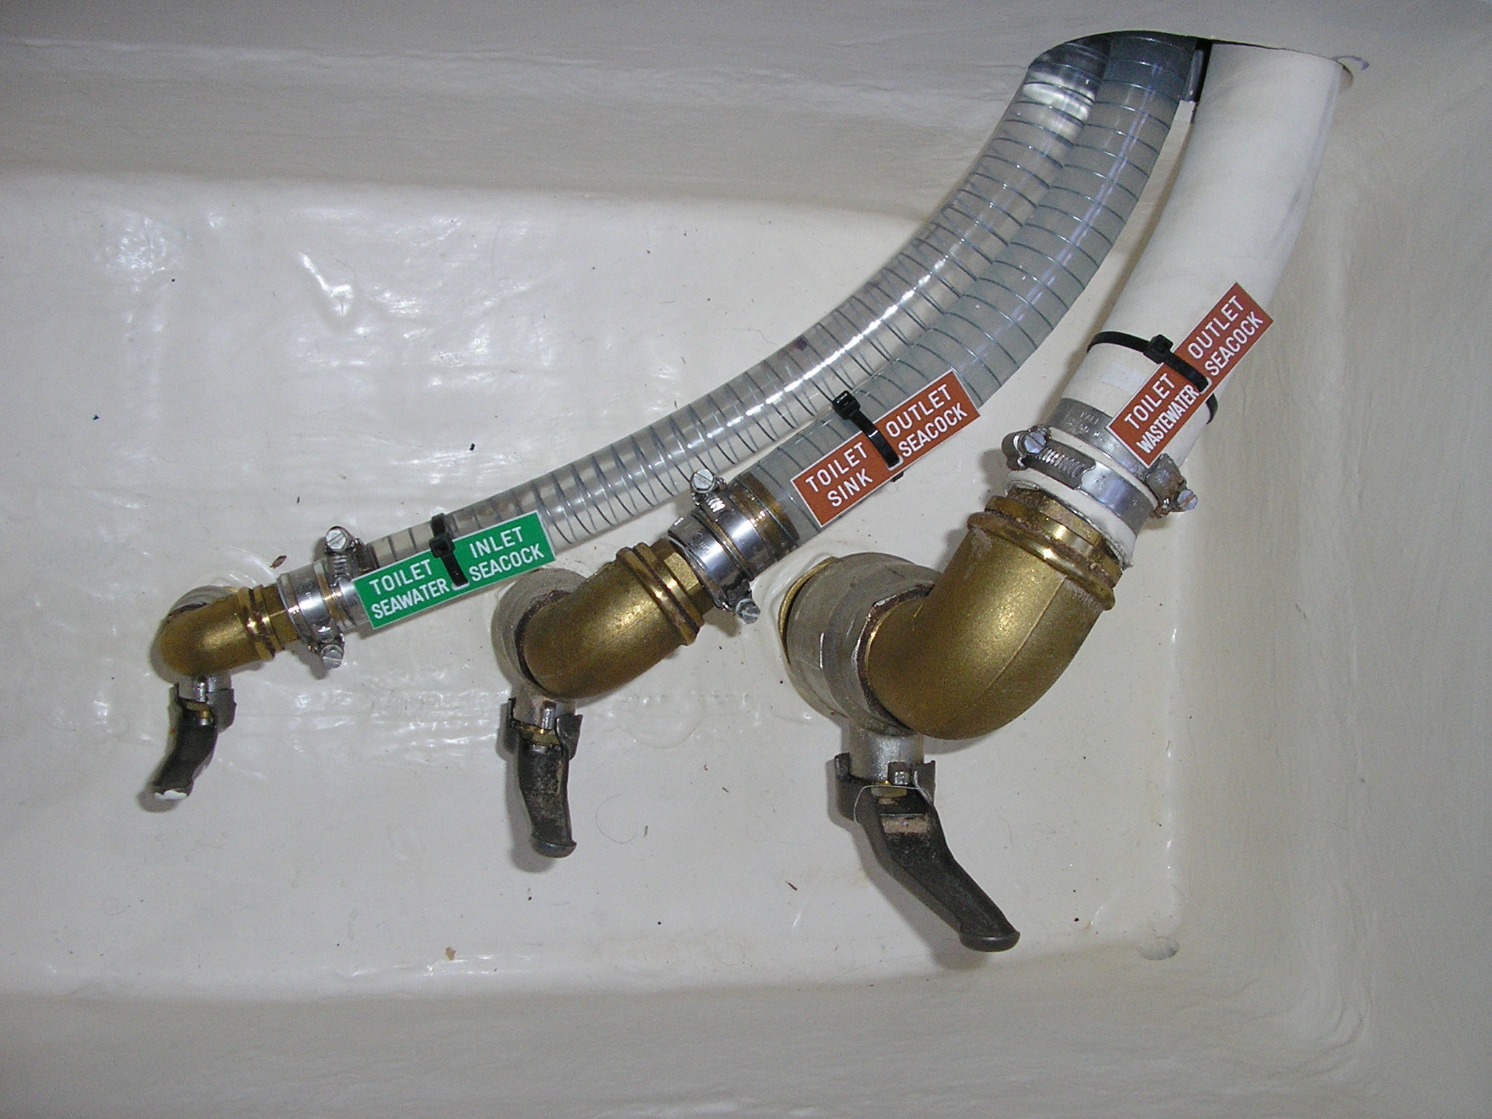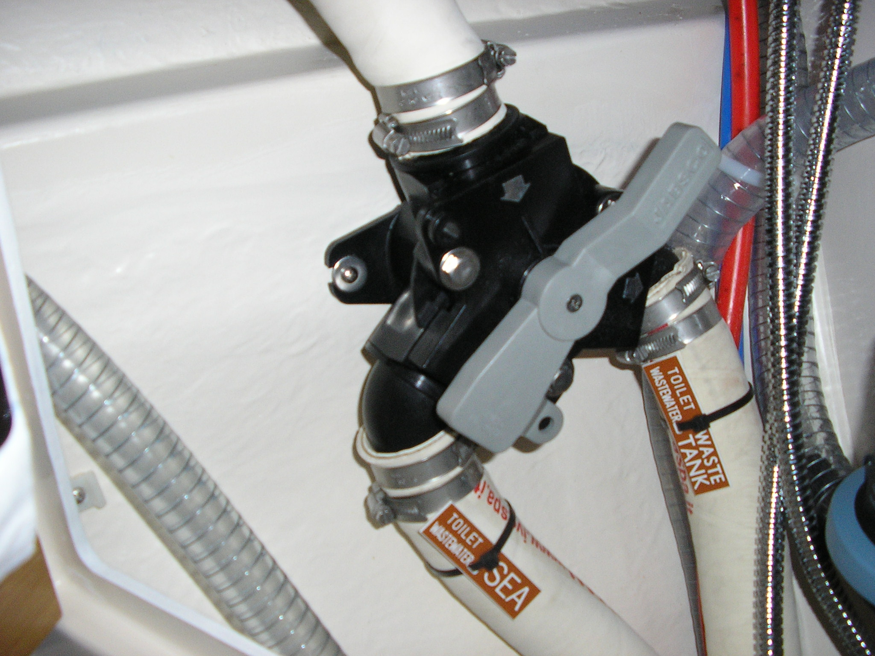
Photo 1. Heads seacocks Photo 2. Waste diverter valve aft head

- Both heads have grey waste diverter valves in the cabinet under the sink see Photo 2. It is very important that the grey valves are set all the way one way or all the way the other. Not half open. Or a siphon action will allow sea water to fill the sewage tank.
- The fat end of the grey handle indicates the direction of the waste flow. The flow direction of pipes on the diverter valve in the forward head is different to the aft head and has been re-labeled.
- Do not flush baby wipes, paper towels, tampons, sanitary napkins, or hair down the toilet. It will block. Try to minimize the amount of toilet paper you use.
- Add Superbowl cleaner fluid to the heads to help break up calcification in the pipes and tank. 100ml once per week.
- Flush through the toilets with fresh water when leaving the yacht unattended for more than a couple of days to limit the smell from dead marine organisms in the seawater in the bowl, inlet and discharge lines.

Blocked pump, blown fuse?
- If the pump is blocked one or both fuses may blow.
- One fuse is in a white plastic sleeve visible behind the pump
- The second reset-able 25A fuse is behind the DC panel and now labelled ‘Toilet’. (was labelled Isotherm/Frig).
- Refer to: SOP22 Macerator pump for instructions on how to unblock or replace the pump.

How to empty the sewage tank
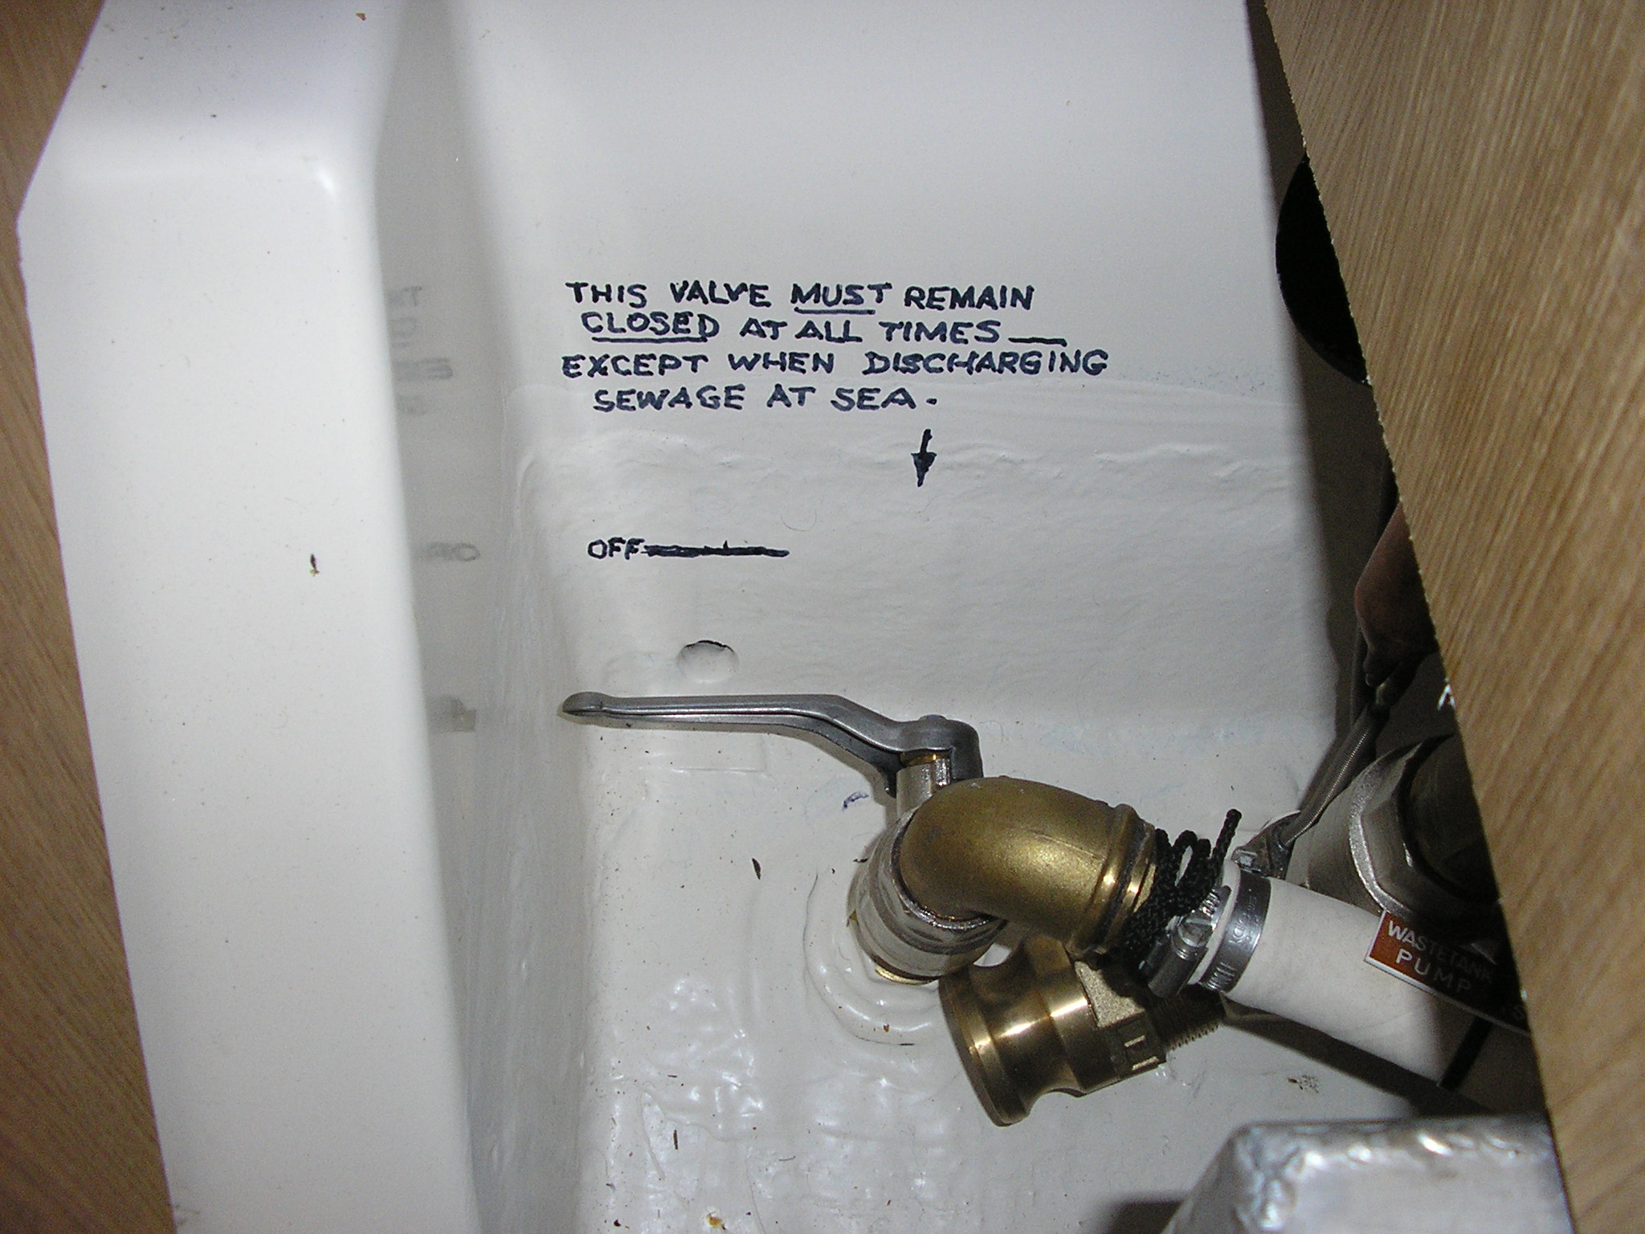
- Under NSW legislation sewage may not be discharged within 1Nm of the coast. Sewage may be discharged at pump out stations.
- The Sewage tank has a pump which pumps sewage up and out to either the pump out station deck outlet or the sewage discharge seacock. The pump is under the central floor under the table.
- Open the sewage discharge seacock shown in Photo 3 at right.
- If possible tack onto Starboard as the pump pickup pipe is on the port side of the tank.
- Switch on the waste water pump on the right hand side of the electrical control panel
- Remove a floor board to listen to the pump.
- Have an observer tell you that the discharge is working.
- When the tank is empty the sound of the pump will change. Turn the pump off. Check the capacity gauge on the control panel. The gauge sometimes gives incorrect readings.
- Flush some sea water into the tank via the aft head and empty the tank again to rinse it.
- Close the sewage discharge seacock

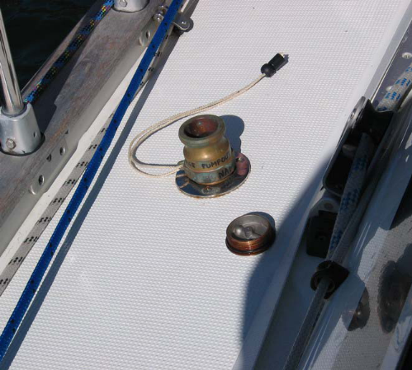
How to empty the sewage tank at a pump out station
- Attach the brass pump out station deck fitting (shown in Photo 3) to the pump out deck outlet see Photo 4. Note: Photo 4 (at right) is from the Bavaria 44.
- The pump out operator will vacuum out the tank contents.
- Check the capacity gauge on the control panel.
- Flush some sea water into the tank via the aft head and empty the tank again to rinse it.

Pump Out Stations
The NSW Maritime website http://www.maritime.nsw.gov.au/locator.html lists pump out stations in Pittwater (and Port Jackson). The Quays Marina listing is:

Quays Marina (Pittwater)
1856 Pittwater Rd
CHURCH POINT NSW 2105
Phone: (02) 9997 2800
Hours of operation: 3:00 pm to 3:30pm, 7 days
Private, fixed, pump-out facility, Fee applies.
Note: Please phone prior to arriving to use facility

Hawkesbury/Broken Bay
d'Albora Marina Akuna Bay
Liberator General San Martin Drive
AKUNA BAY NSW 2084
Phone: (02) 9486 3000
Hours of operation: 8:30am to 5:00pm, 7 days
Private, fixed, pump-out facility, Free to use, available to the public
Gosford Boat Harbour Public Wharf (Brisbane Water)
Memorial Drive
GOSFORD NSW 2250
Phone: (02) 4365 1593
Free to use public pump-out facility operated by Gosford City Council that can be accessed 24
hours.

Holidays Afloat Houseboats
65 Brooklyn Rd
BROOKLYN NSW 2083
Phone: (02) 9985 7538
Hours of operation: 8:00am to 4:00pm, 7 days
Public, fixed pump-out facility, Fee applies.
Kangaroo Point Pump-out
Off Pacific Hwy (mouth of Sandbrook Inlet)
BROOKLYN NSW 2083
Phone: (02) 9847 6766
Hours of operation: daylight hours, 7 days
Public, fixed pump-out facility
Free for recreational vessels; fee applies for commercial vessels. Administered by Hornsby Shire Council. Facility for waste from portable toilets also available

